Progress report

June 2016

Honors, Masters & PhD Progress Report Form

This form is the means by which progress of Postgraduate studies is periodically assessed by the student and supervisory team, and reported to SANSA. It is a means by which any problems or issues may be identified and appropriate action determined. The South African National Space Agency uses this form to monitor students’ progress and ensure that supervision is effective. The regular submission of progress reports is required and failure to fulfill this may lead to termination of bursary.

Form should be completed and returned as an email attachment sent to the Grants Administration Office (students@sansa.org.za)

This form has three parts:

PART A: Progress Report – to be completed by the Student

PART B: Comments – to be completed by the Primary Supervisor on behalf of the Supervisory Team

PART C: Recommendations and Signatures – to be completed by the Student, Supervisors, and Head of Department/School or nominee

PART A: PROGRESS REPORT - STUDENT COMMENTS

Name | Dugal Harris
Student Number | 17447585 | Degree date of first enrolment: | 2015/01
Department/University: | Geography and Environmental Studies/ Stellenbosch University | Name of any scholarships received: | NRF Innovation
Enrolment Status | Full-time | Part-time

Supervisory team

Primary Supervisor Prof. | Adriaan Van Niekerk
Co-Supervisor 1
Co-Supervisor 2
Outline below your progress and achievements over the last 6 months. Indicate what milestones have been achieved, including detailing what chapters or sections of your thesis have been written indicating in draft or final form.

In the last 6 months:

- Improvements to radiometric calibration image boundary treatment and regeneration of results
- Further work on developing theoretical basis for radiometric calibration
- Establishing the relationship between sensor measured (“band averaged”) values (relating to radiometric calibration)
- Reworking of radiometric calibration chapter with new results into paper
- Initial work on gathering data for carbon stock ground truth
- Engaging with WWF and other stakeholders to co-ordinate future carbon stock research

Chapters written(Draft):

”Retrieval of surface reflectance from aerial imagery by calibration with satellite data” (referred to above as “Radiometric calibration”) (Chapter complete and ready for first journal submission)

In The Next 6 Months:

- Planning and data/image gathering for carbon stock mapping
- Data preparation and calibration
- Preparing of next 2 chapters into papers for journal submission
Chapters to be written:

- Feature clustering and ranking
- Very high resolution mapping of Spekboom canopy cover

Outline below your research goals for the next 6 months. Indicate what milestones have been set for the next 6 months, including detailing what chapters or sections of your thesis you plan to write in this period.

- I rate the quality of my work as:
a. Very Good c. Satisfactory
b. Good d. Below my expectations

- I assess my rate of progress as:
a. Very Good c. Satisfactory
b. Good d. Below my expectations

If (d) what measures have you taken to address this?

- In the past 6 months I have:
Given a departmental seminar? Yes No
Attended a conference(s)? Yes No
Given a presentation(s) based on my research? Yes No
Had research output(s) published
(e.g. journal articles; book chapters; conference proceedings; creative works)?
Yes No

If Yes, please give details

- I have submitted work to my supervisory team Yes No
I have received written feedback Yes No

- I have outstanding resource issues concerning my research Yes No

If Yes, please give details

- Are there any intellectual property(IP) issues related to my research that have not been resolved , or do you foresee any IP related issues? Yes No
If Yes, please detail:

- How often and by what means do you and your supervisory team maintain contact?
Bi-weekly face-to-face meetings and or email contact
Detail the means of contact (e.g., face-to-face; email; Skype) and the frequency of each

- Contact with my supervisory team could be improved? Yes No

- Please provide details below of any way that you think your supervisory team could improve its support of your studies

- Do you have any concerns with your English language skills (e.g., reading, writing, speaking, listening) in respect to your PhD work?
Yes No

If Yes, please detail:

If yes, please describe these concerns and indicate whether you have sought any support or advice for these concerns (e.g. from your supervisor or from a Learning Skills Centre)

- Do you have any concerns with your English language skills (e.g., reading, writing, speaking, listening) in respect to your work?
Yes No

If yes, please describe these concerns and indicate whether you have sought any support or advice for these concerns (e.g. from your supervisor or from a Learning Skills Centre, or the SANSA English Tutor)

Please now forward the form to your supervisor

PART B: SUPERVISORY TEAM COMMENTS

Please provide comments on the student’s progress and achievements in the last 6 months:
I can confirm that the student’s is making good progress (as he reported in the previous section)

Please provide comments on the student’s thesis goals and milestones for the next 6 months:
See the student’s plan above. I think the goals for the next 6 months are realistic.

- The quality of the student’s work is:
a. Very good c. Satisfactory
b. Good d. Below acceptable standard

If (d) what measures have been taken to address this?

- The student’s rate of progress is:
a. Very good c. Satisfactory
b. Good d. Below acceptable standard

If (d) what measures have been taken to address this?

- How often and by what means do the supervisory team and the student maintain contact?
Every two weeks.
Detail the means of contact (e.g., face-to-face; email; Skype) and the frequency of each
Mainly Face to face
- Is the supervisory team satisfied with the frequency and means of contact?
Yes No
If No, please comment:

- Do you have any concerns about the student’s English language skills (e.g., reading, writing, speaking, listening) in respect to his/her work?
Yes No

If yes, please describe these concerns and indicate whether you have offered support or advice to the student and/or directed them to support services (e.g., Learning Skills Centre)

- Are there any intellectual property (IP) issues which have not been resolved, or do you foresee any IP related issues?
Yes No

If Yes, please comment:
Not sure what is meant by issues, but the IP of the work belongs to the student, the supervisor and the university. It is likely that a patent will be filed as an outcome of this research.

- Are there any issues that the HOD/HOS or the Dean of Postgraduate Research should be aware of? Yes No
If Yes, please comment:

PART C: RECOMMENDATIONS AND SIGNATURES

C1 Primary Supervisor to complete

I recommend that the student’s enrolment be:

X Continued
Continued subject to specified conditions as outlined below
Terminated

Specified conditions of continued enrolment:

I have discussed our comments with the student: Yes No

Please outline any issues that emerged from the discussion with the student:

All members of Supervisory Team to sign below.

_

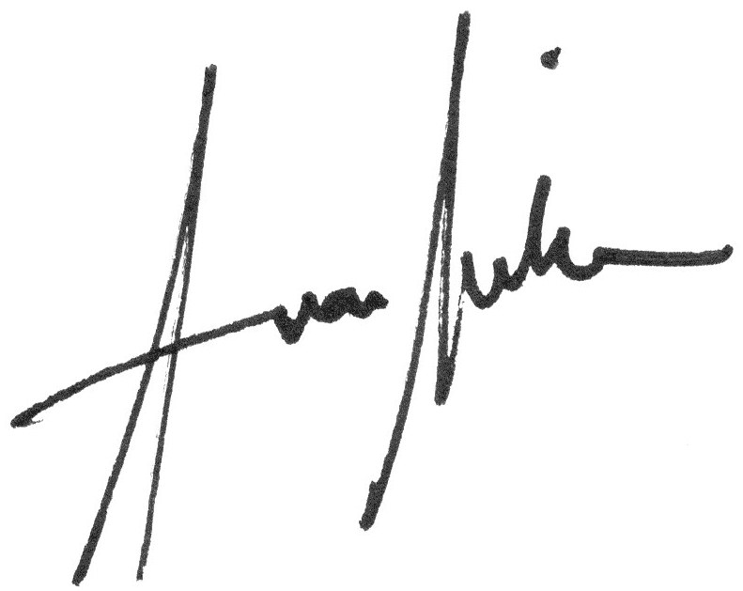
_______________________________ 28 June 2016
Signature of Primary Supervisor Date

________________________________ ____________________
Signature of Co-Supervisor 1 Date

________________________________ ____________________
Signature of Co- Supervisor 2 Date

Please now return the form to the student.

C3 Student to complete

If you would like to make any comments in response to the comments made by your supervisory team please do so in the box below:

I have discussed this progress report with my supervisor: Yes No

Please outline any issues that emerged from the discussion with your supervisor(s):

Did you complete all the sections required and assisted in giving the supervisor/s the relevant sections to complete?

Yes No

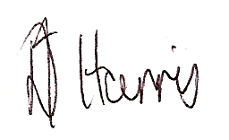
________________________________ __27/6/2016_____________________
Signature of Student Date

Please now forward the form to students@sansa.gov.za as appropriate.

C3: SANSA Grants Administrator to complete

Please comment below on the student’s progress and goals and on the comments made by the student and by the supervisor(s). If any concerns have been raised by either the student or supervisor, please indicate what actions have been taken and any further action you recommend.

I recommend that the candidate’s enrolment be:

Continued
Continued subject to specified conditions as outlined below
Terminated

Specified conditions of continued enrolment:

________________________________ ____________________
Signature of Grants Administrator Date

C4: Managing Director to complete

Acting on behalf of SANSA, I have resolved that this progress report be:
Approved
Declined

I resolve that the candidate’s enrolment be:
Continued
Continued subject to specified conditions as outlined below
Terminated

Specified conditions of continued enrolment:

________________________________ ___________________
Signature of Managing Director Date

Comments:

